EXPERIMENT – 15 Create a Snapshot of a VM and Test it by loading the Previous Version/Cloned VM using Vmware workstation.
Aim:
To create a snapshot of a virtual machine and test it by reverting to the previous state/cloned VM using VMware Workstation.
Procedure:
- Open VMware Workstation and power on the desired virtual machine.
- Configure and run the VM until it reaches the state you want to save.
- From the menu bar, go to VM → Snapshot → Take Snapshot.
- Enter a name and description (e.g., “Before software installation”).
- Click Take Snapshot to save the current state of the VM.
- Make some changes inside the VM (e.g., install/uninstall software, edit files).
- To test, go to VM → Snapshot → Revert to Snapshot.
- The VM will reload the previous saved version, discarding the recent changes.
- Alternatively, you can use Snapshot Manager to manage, restore, or clone snapshots.
- Verify that the system successfully returns to the saved state.
Output:
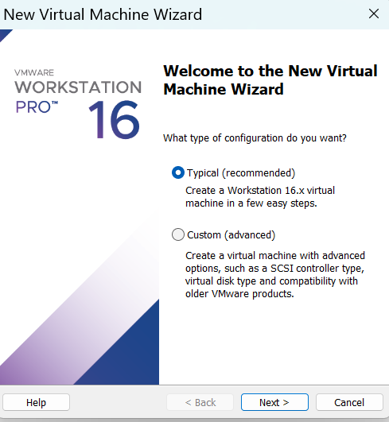

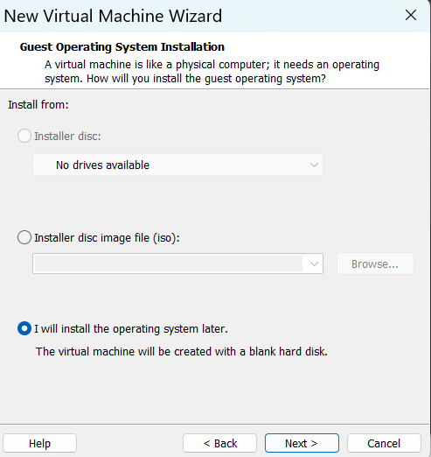

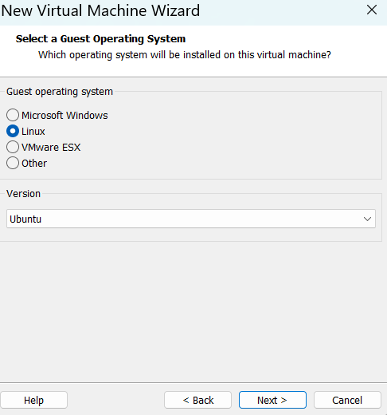

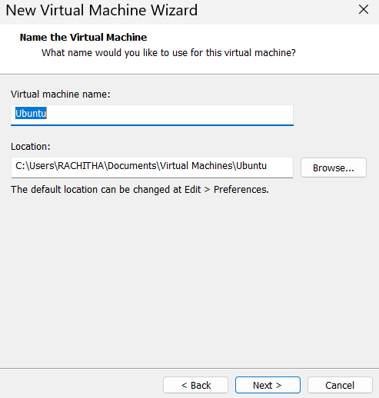

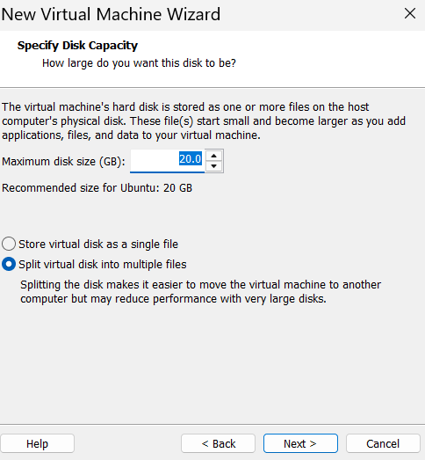

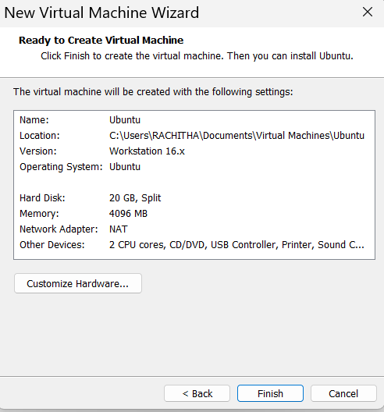

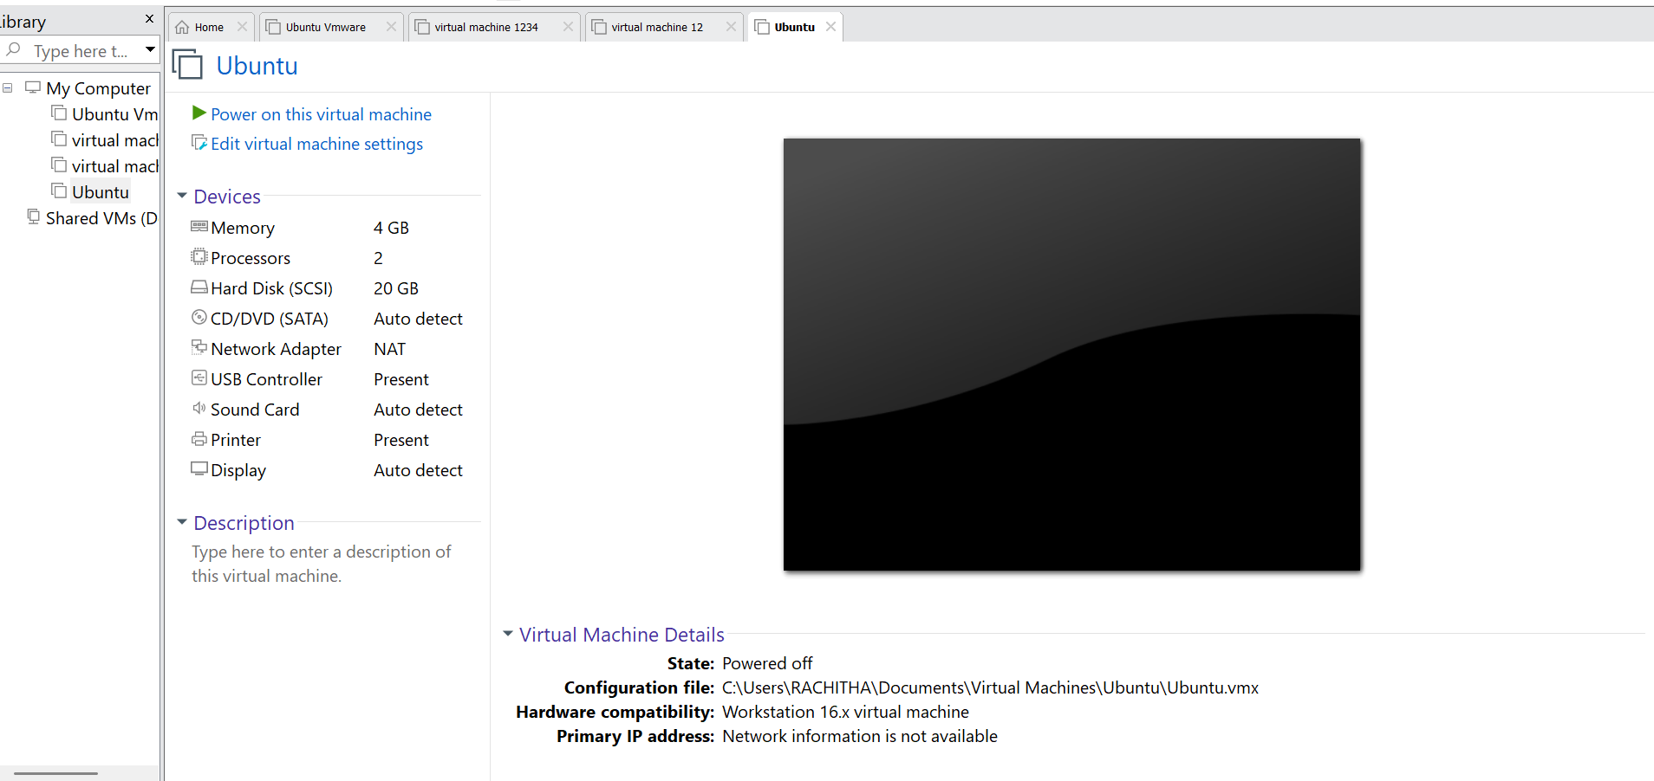

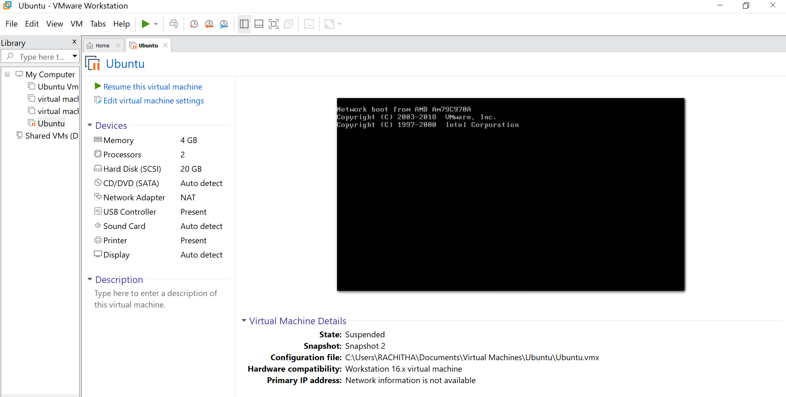
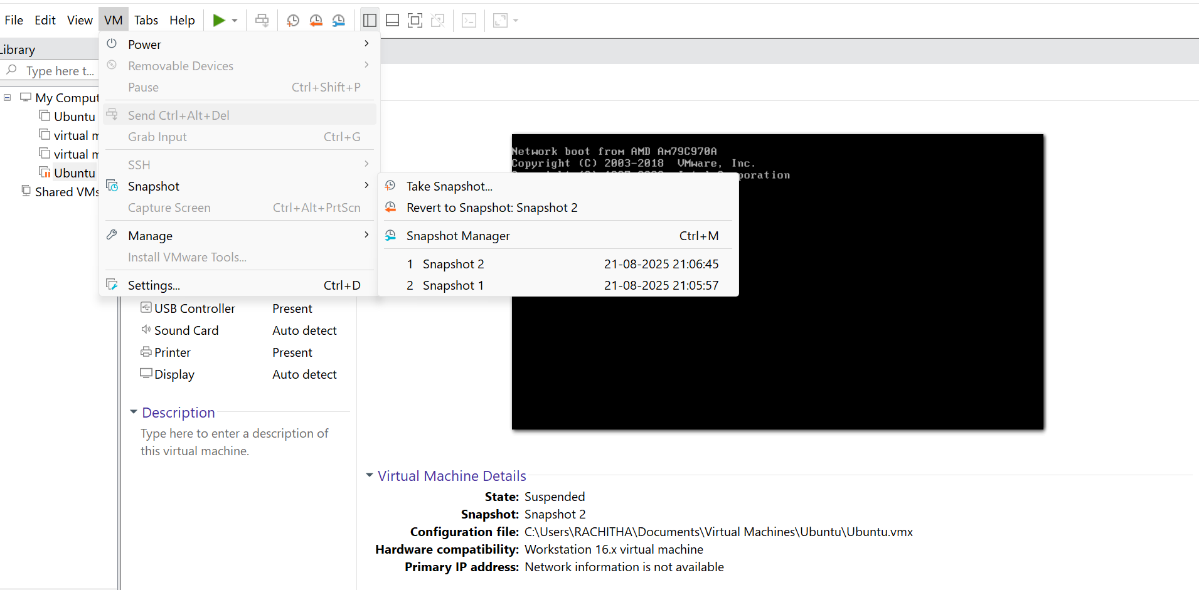
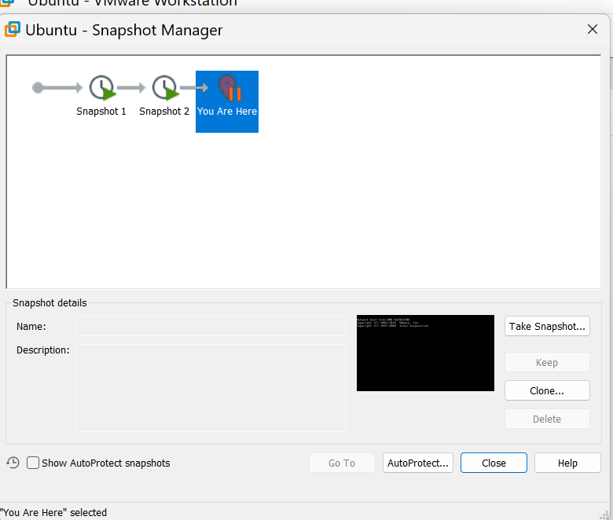
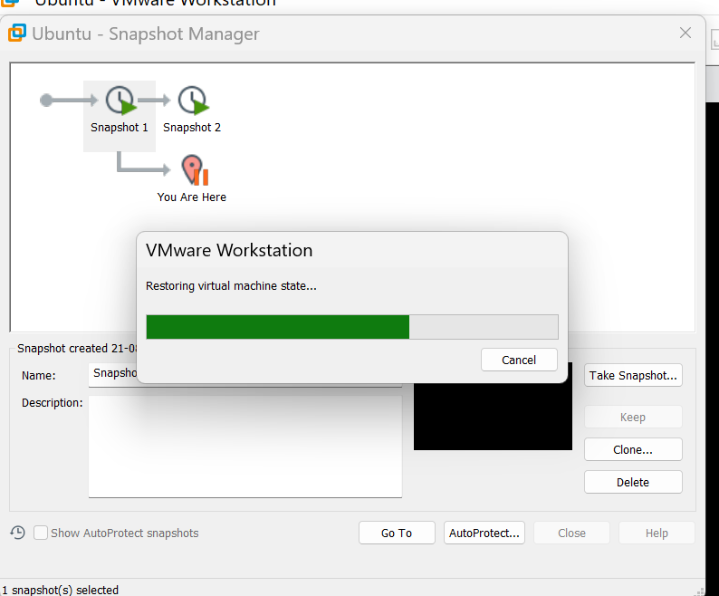

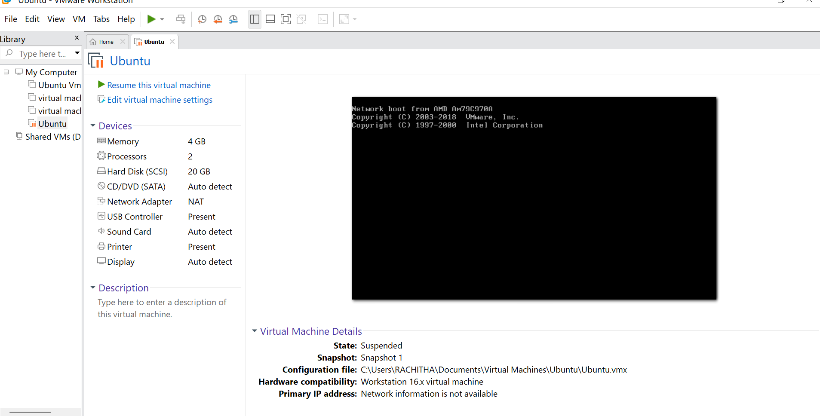

Result:
A snapshot of the VM was successfully created and tested by reverting to the previous version using VMware Workstation. The VM restored its earlier state, demonstrating snapshot and cloning functionality.

